Name: _________________________ Block: _______________

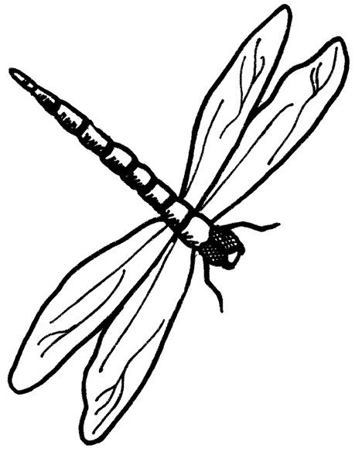
Honors Unit 3 Calendar: Genetics

Date: | Date: | Date: | Date: | Date:
Powerpoint: Meiosis  Meiosis Flip Book  TBT: 11-4 | Powerpoint: Mendelian Genetics Pt 1  Punnett Squares Pt 1 | Investigating Inherited Traits  TBT: 11.1-11.2 | Notes: Mendelian Genetics Pt 2 | Biofly Lab  TBT: 11.3- 14.1

Date: | Date: | Date: | Date: | Date:
Midway Quiz & Notebook Check  Midway Refelction  TBT:  14.2 | Powerpoint: Modes of Inheritance | Powerpoint: Genetic Diseases and Pedigrees | Review  Final Reflection | Unit 3 Exam

