Name: _____________________________
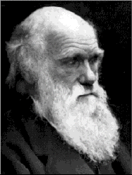

Date: _____________________

Block: _______

Evolution Practice Test
(May 6, 2014)

Part I. Match these evolution terms to their definitions (15 pts)

Word Bank
Artificial selection; Bell curve; Bottleneck; Descent with modification; Evolution; Founder effect; Gene flow; Genetic drift; Macroevolution; Microevolution; Mutation; Natural selection; Speciation; Species; Uniformatarianism.

1. Random, accidental change to DNA: ____________________________

2. The natural forces and processes that shape the earth now are the
same forces that shaped the earth millions of years ago:

___________________________________________

3. Change in allele frequency over time: ______________________________

4. Organisms with traits that are well-suited to their environment survive and reproduce at a greater rate:

___________________________________

5. Graph of normal distribution: ________________________________

6. The formation of new species: ________________________________

7. AKA Selective breeding. Man intentionally breeding certain desirable traits:

________________________________

8. A large population is dramatically reduced to a few individuals (e.g. disasters,
hunting):
________________________________

9. All life on earth descended from a common ancestor over millions of years:

________________________________

10. A small group branches off and colonizes a new area:

________________________________

11. Change in the gene pool that takes place as a result of chance (not natural
selection):

________________________________

12. Organisms that can interbreed: __________________________________

13. Evolution over shorter periods of time. Changes are adaptations
within a species:

________________________________
14. Evolution on a grand scale. Microevolution over millions of years. Speciation
occurs:
________________________________

15. Change in allele frequency due to migration (“restocking”) _________________

Part II: Fill-in short answer.

16. List Darwin’s 5 principles of evolution. (5 pts)

1. ______________________________________________________________________

____________________________________________________________

2. ______________________________________________________________________

_____________________________________________________________________

3. ______________________________________________________________________

_____________________________________________________________________

4. ______________________________________________________________________

_____________________________________________________________________

5. ______________________________________________________________________

_____________________________________________________________________

17. Does natural selection act on the phenotype or the genotype? Explain.

a. _________________________________ (1 pt)

b. ______________________________________________________________________

__________________________________________________________________ (1 pt)

18. Which kind of natural selection does this graph show?
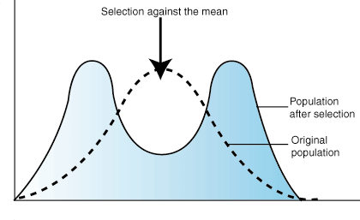

___________________________________ (1 pt)
19. Which kind of natural selection does this graph show?
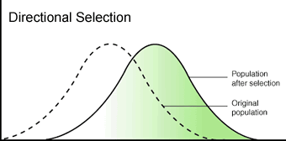

___________________________________ (1 pt)

20. Which kind of natural selection does this graph show?
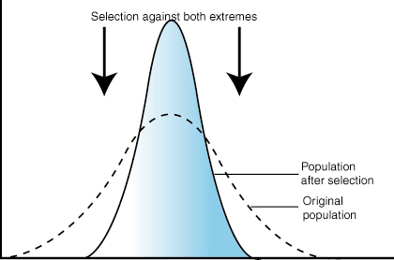

___________________________________ (1 pt)

21. What are 4 examples of “prezygotic” (premating) mechanisms that exist in
nature that create genetic isolation (thus speciation)? (eg. Brown bear won’t mate with black bear) (4 pts)

1. __________________________________________________________________

2. __________________________________________________________________

3. __________________________________________________________________

4. __________________________________________________________________

22. What are 4 examples of “postzygotic” (post-mating) mechanisms that exist in
nature that create genetic isolation (thus speciation)? (eg. Brown bear won’t mate with black bear) (4 pts)

1. ____________________________________________________________________

2. ____________________________________________________________________

3. ____________________________________________________________________

4. ____________________________________________________________________

23. What do the following prefixes mean? (12 pts)

a. Micro: _________________ b. Macro: ____________ c. Hyper: _____________

d. Hetero: ________________ e. Homo: _____________ f. Bio: _____________

g. Poly: ________________ h. Anti: ______________ i. Hypo: _____________

j. Cyto: ________________ k. Semi: _____________ l. Bi: _____________

24. What is the difference between artificial selection and natural selection? (2 pts)

25. What does this diagram represent? (2 pts)
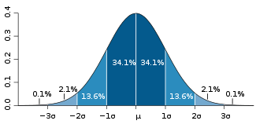

_________________________________

26. Based on these amino acid sequences, write down the number of differences
for each comparison. (2 pts)
Humans – LEU GLU VAL CYS VAL HIS GLU HIS
Turkeys – LEU VAL VAL CYS ALA HIS GLU HIS
Chimps – LEU GLU VAL CYS VAL HIS GLU PRO

Species Comparisons Number of Differences

- Human and Turkeys ________________________ . (1 pt)

- Human and Chimps ________________________ . (1 pt)

- Turkeys and Chimps _________________________ (1 pt)

27. Which pair of organisms in question 26 have the closest evolutionary
relationship? (1 pt)
__________________________________

28. Write out an example (a scenario) of natural selection occurring? (2 pts)

