DNA Fingerprinting
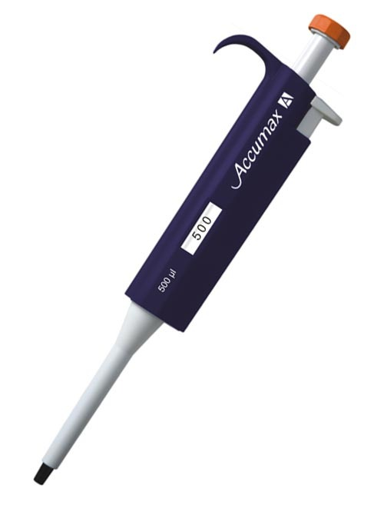
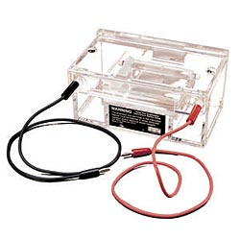
(April 21, 2014)

When you try to look at DNA in a test tube, it all looks the same. By simple observation, it is impossible to tell the difference between two samples of DNA. However, a technique has been developed which allows forensic scientists to compare two sets of DNA. Like fingerprints help identify individuals present at a crime scene, DNA is an even more accurate way of isolating an individual. Everyone has a unique set of DNA so matching DNA found at a crime scene to an individual is virtually foolproof. This new technology has saved lives. For example, consider The Innocence Project. They are a non-profit organization that is dedicated to exonerating wrongly convicted people through the use of DNA Testing. The Innocence Project was established after a landmark study in the early 1990s showed that incorrect identification by eyewitnesses was a factor in over 70% of wrongful convictions. Some of the Innocence Project's successes have resulted in rescuing innocent people from death row. In fact, the successes of this organization has fueled more and more American opposition to the death penalty.
How is DNA “Fingerprinting” done? First the DNA is gathered from live tissue found at a crime scene (e.g. saliva, skin cells, white blood cell, sperm, bone, hair follicle), as well as DNA gathered from suspects. Each sample is processed. The samples are then introduced to a restriction enzyme. The same restriction enzyme! Because they cut DNA, restriction enzymes are the “chemical scissors” of the molecular biologist. When a particular restriction enzyme “recognizes” a particular sequence on a segment of DNA, it cuts the DNA molecule at that point. The recognition sequences for two commonly used enzymes, Bam HI and Hind III, are GGATCC and AAGCTT, respectfully. The place on the DNA backbones where the DNA is actually cut is shown with the black line.

GGATCC AAGCTT
Bam HI: CCTAGG Hind III: TTCGAA

In order for the enzymes to cut the DNA, they must be warmed to 37ºC. This happens to be the same temperature that our bodies are at and our enzymes work their best.
Each individual, except in the cases of twins, has a unique DNA sequence. Since restriction enzymes cut DNA at the same sequence all the time, the resulting size of the DNA fragments will be UNIQUE for each individual. This is the power of DNA fingerprinting.
The next step is gel electrophoresis. A gel made of agarose, a seaweed extract similar to gelatin, is prepared and placed into a chamber filled with a conductive liquid solution. The gel has a consistency similar to very firm jello. This consistency offers resistance to the pieces of DNA as they are pushed/pulled through the gel. The gel is prepared with small wells at one end so that DNA samples can be loaded into the gel. The various suspects and crime scene DNA fragments are loaded into separate wells.
A direct current is passed between wire electrodes at each end of the chamber. Because DNA is negatively charged, when they are placed in this electrical field, the fragments will be drawn toward the positive pole and repelled from the negative pole. As the pieces of DNA move through the gel, they will meet with resistance. Larger pieces of
DNA will have more difficulty moving through the gel than smaller fragments. This allows separation of all different sizes of DNA fragments. Consequently, electrophoresis separates DNA fragments according to their relative size. Fragments of the same size stay together and migrate to form “bands” of DNA.
By comparing the band patterns of the various well “lanes”, one can match the crime scene lane with the suspect’s lane, to see if the bands line up the same.

DNA FINGERPRINTING LAB PROTOCOL

Every time you complete a step, place a check in the box to the left of the
instruction. This will help insure that you don’t skip a step. Remember, your grade for this lab will reflect your results. Have a reader read each step !!

Part I: DNA Preparation/Digest (Cutting)

- Obtain a ‘floatie’ with the following SIX labeled microtubes:
CS (Crime Scene)
Check
S1 (Suspect 1)
S2 (Suspect 2)
S3 (Suspect 3)
S4 (Suspect 4)
S5 (Suspect 5)

- Using the microcentrifuge, place the six tubes in the proper holes and
Check
make sure the centrifuge is balanced. Pulse the centrifuge for only 2-3
seconds. This will ensure that the entire sample is at the bottom of the microtube. Remove the tubes from the centrifuge.

- Locate the clear microtube which contains the Restriction Enzyme/Buffer solution. Using a micropipette, transfer 5.0 uL of this solution to each
Check
of the six microtubes that were centrifuged. Place the drop of this solution on the side wall of the tube, to be sure you have released the drop of solution.
NOTE: If the tip accidently touches any of the liquid in one of the tubes, change the tip !! Do not contaminate one suspect’s DNA with another’s. When in doubt, change the tip !

- To mix the contents of each of the six tubes, close all the caps and place
Check
the tubes in the centrifuge once again. Pulse the centrifuge for only
2-3 seconds. This will be sufficient to mix all of the liquids. Remove the
tubes from the centrifuge.

- Place the six tubes back in the floatie and incubate in the warm water
Check
bath, which is set at 37ºC. Let them sit for 45 minutes. This will provide
the enzymes the proper temperature and the time it needs to cut the DNA.

- Go back to your seats and answer the first eight questions attached to the lab handout
Check

Part II: Practice Gel Loading
It is time to practice loading your DNA gels. You will be adding loading dye to your DNA samples. This solution will turn your DNA samples dark blue and make your sample heavier than water. It will sink to the bottom of your gel well and stay in the proper chamber when the electricity is run through the gel.

- Obtain a petri dish filled with gels and water.
Check

- Obtain your ‘practice DNA’ sample dye (black food coloring and glycerol).
Check

- Draw out 5uL of this practice dye from its microtube. Place the tip of the
Check
pipette in a well and expel the sample into the well. Make sure you do not go too deep into the well because you can easily tear it. Do not release the plunger until you have removed the pipette tip from the petri dish. When you have done 5 or so, give your lab-mates the opportunity to practice as well.

Part III: Gel Loading

- Retrieve your DNA samples from the water bath (or get them from your teacher if done the next day).

Check
2. Obtain a tube filled with Loading Dye “LD”. Change the value on the side of your micropipette to 2 uL (GENTLY please). Pipette 2 uL of loading dye into each of your six DNA samples. Remember to put the drop on the side of the tube to be sure you have inserted the dye. The dye will stain the DNA and make the DNA solution heavier than water (so it stays in the wells).

Check
3. Obtain the Lambda Hind III DNA Size Marker ‘M’ from your teacher. This sample will be used to ensure the process has run properly when the test is complete.
Check

4. Centrifuge the six DNA samples for 4-5 seconds. This will be long enough to mix your solutions.
Check

5. Change the value on the size of the micropipette to 10 uL. BE GENTLE. Using a separate tip for each sample (so as to not contaminate each s specimen) load 10 uL of sample into the electrophoresis gel wells. The gels are read from left to right so, with the wells in front of you (“south” vs. “north”), starting with the well to the farthest left…
Check
Load them in order.
Lane 1 Hind III DNA size marker
Lane 2 CS
Lane 3 S1
Lane 4 S2
Lane 5 S3
Lane 6 S4
Lane 7 S5

6. Secure the lid of the gel box. It will only fit in one direction. Remember, DNA is negatively charged and will be attracted or move to the positive side of the gel. Make sure the gel wells are closest to the black wire. If you have made a mistake and things look backwards, see the instructor for help. Connect the electrical leads to the power supply. Put the black circle and the red lead into the red circle. When your group is finished, return to your seats and work with your group on the questions. Notify your teacher, that you are ready and he/she will turn the chambers on.
Check

6. The DNA requires approximately 30 minutes of 100 Volts to separate completely. You can tell an electric current is running when small bubbles
Check
begin to form at both ends of the gel box. As the DNA migrates through the gel, it will pick up the blue stain in the gel. The longer it runs, the darker the bands become and the further they are separated.

Part IV: Staining Your Electrophoresis Gel

- Make sure the Power supply is turned off and carefully slide the gel out of your gel box into a plastic tray provided by your instructor.
Check

- Being careful not to spill blue stain all over you, the counter or the floor, cover the gel with staining solution. This staining solution is not harmful, but it will stain your skin and clothing.
Check

- Allow the gel to remain covered overnight.
Check

Part V: Analyzing Your Electrophoresis Gel

- Pour the staining solution into the sink. Cover your gel with clear water and allow it to stand for 5-10 minutes.

- After 10 minutes, pour the water into a sink.

- First look at Lane 1 to be sure the DNA size marker separated. If 5-6 bands or more are visible, this is AWESOME. 3-4 is GOOD.

- Look at Lane 2 which is the sample from the crime scene. The person it belongs to has an identical looking DNA pattern in one of the other wells in your gel. Try to match Lane 2 to one of the four suspects.

