Extra Credit – Cedar Creek Falls Hike
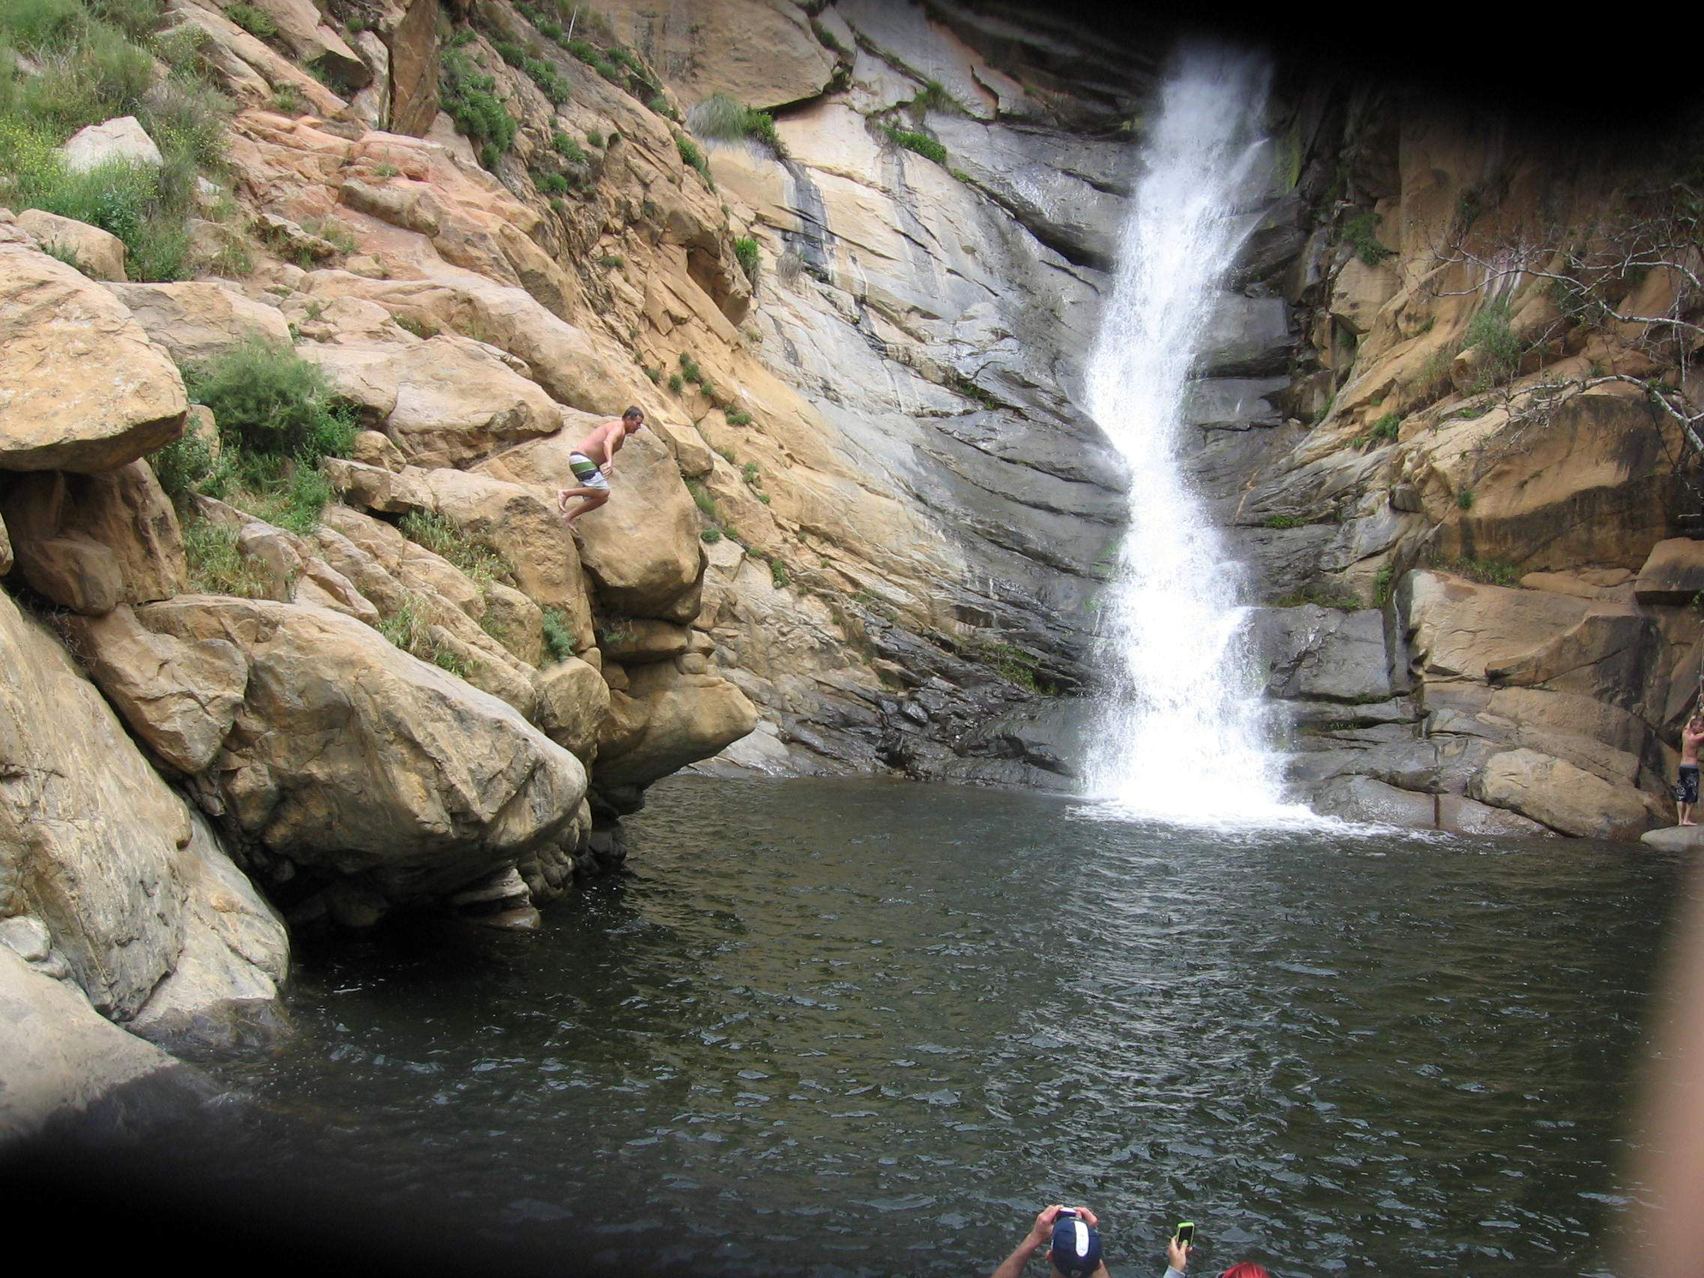

Important Considerations Before Hiking:
- Tell your parents where you are going. Give them a copy of this paper, so in case something happens, they can help rangers locate you. We did not get good
cell-phone reception.
- Go with someone (it’s more fun and safer). Take your parents (they will enjoy it) or a friend.
- You will need a permit (they only allow a certain amount of people to go each day) and an Adventure Pass to park at the Trailhead Recreation Area. They are $5 for a 1-day use and can be purchased at the Ranger Station in Alpine (3348 Alpine Blvd).
- Be aware of rattlesnakes. On my last trip there was one in the middle of the trail in a grassy rut. Luckily it rattled as we neared it which saved us from its strike. We also saw a different one on the way back to the car, off to the side of the path. So two of them on the same trip !!
- Think about starting early in the morning before it gets too hot. In the afternoon on the way up, it could be very hot. Also consider taking a lunch and relaxing for a while at the bottom of the falls. There are lots of rocks to sit on.
- Dogs are allowed (don’t forget to bring water for them as well). Don’t let them get bit by rattlers.

Things to Take in your Backpack:
- PLENTY OF WATER !! (at least 1 quart per mile).
- A lunch.
- Camera.
- Extra pair of dry socks; dry shirt for trip back up to car.
- Water-shoes (or sandals) to cross the creeks.
- Small towel to wipe your feet after the creeks (or to dry yourself, if you go swimming at the base of the falls).
- Hat.
- Sunblock.
- Ziplock bag with First Aid items (Band-aids? Wipes? Gauze? Medical Tape?)
- Take this hand-out, but don’t lose it, so you have directions on how to get home.

Hiking Distance: About 4.5 miles round trip.

Difficulty: Moderately strenuous. Those who are “in shape” will consider it easier
(moderate?). I made it easily and I’m 55 years old, and fat! Hikers get in trouble simply because they don’t bring enough water for the sweaty, uphill climb back to the trailhead.

Notes of interest: This is one of San Diego County’s hidden treasures. It is a fantastic
Get-away for any nature lovers or adventure seekers. You will be shocked so many times, and won’t believe this is in San Diego! The trail has inspiring views of looming mountains and drastic valleys and ends in a very rewarding waterfall scene, complete with a large pool (if you don’t mind cold water). The best time to go (maximum water flow) would during a raining season). The falls will not be as dramatic in the summer or dry fall months). You will have to cross 3 creeks and if the water is high (it was, the day I went), it is difficult and maybe dangerous to cross the creek by jumping on the rocks (they are slippery and wobbly). The water is also cold. I recommend putting on water shoes and just walking across (safer than barefoot). The creeks are all within a couple of 100 yards of each other so keep the water shoes on until you cross all of them.

Driving to the trailhead: From interstate 8 east, exit at Highway 79 (to Julian), and
head north. After several miles, you will have to make a left to stay on 79 (watch for signs). Go through Julian, and make a left to stay on 78/79. Drive to Pine Hills Road, which intersects highway 78, which is about 1 mile west of Julian. Turn left on Pine Hills Road. After 1.5 miles on Pine Hills Road, bear right on
Eagle Peak Road. After 1.4 more miles, veer right again, staying on Eagle Peak Road. Now you face 8.2 miles of progressively poorer dirt roads. Drive carefully, the road is not very wide, yet it’s a two way highway. There are some very steep drop offs, with no rail to stop your fall.

Trail Directions: The path starts at the sign “Saddleback”. As you descend, look up the
canyon to the North and you will see Mildred Falls, arguably San Diego County’s highest waterfall at more than 100 feet. As the trail winds downward, you will enjoy a splendid view of the V-Shaped upper San Diego River Canyon. After about 1.4 miles down, there is a spur trail that heads upward; stay on the trail downward. At the bottom of the trail you will pass some metal railings. Several roads will converge here at the bottom. Turn left to head to the waterfall. In about a quarter of a mile, you will start crossing the creeks; and you will be close to the falls.

To Confirm and Receive the Extra Credit: Take some pictures of the falls, with you in
the picture. YOU MUST APPEAR IN THE PICTURE TO CONFIRM YOU WERE THERE !! Show me the pictures. Secondly, write a short, half-page reflection. When did you go (day and date)? Who did you go with? What did you think of the sights while hiking? What were your favorite things about the day? What was the worst thing? Was it fun?

