Bacterial Transformation Lab Protocol (Bio-Rad)
(October 28, 2013)

CHECK OFF EACH STEP AS YOU READ IT THOROUGHLY AND FOLLOW THE DIRECTIONS

1. Label your three agar plates on the bottom (NOT THE LID). Label the plates
as follows:

LB -
LB/amp +
LB/amp -

2. On their lids, label the two micro testtubes as follows:
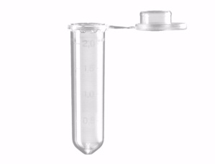
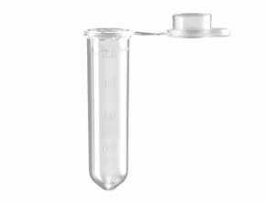

Lids

+
-
The + indicates the micro testtube that
will receive the plasmid with the two
genetically engineered genes on them,
while the - indicates the micro testtube that will not receive the plasmid.

3. Place them in the foam “floatie”.

4. Using a plastic disposable pipette, transfer .250 ml of CaCl₂, to both tubes, close and place them on ice for at least 2 minutes.

.100 ml
.5 ml
1.0 ml
.250 ml
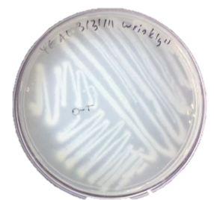
5. Using a sterile loop, gently & lightly (don’t
dig out any agar) scrape off 4 colonies of
bacteria off the surface of the “starter plate”

6. Transfer the colonies of bacteria
to one of the micro tubes. Swirl,
spin and twist the loop to make
sure all of the bacteria mixes with
the CaCl₂ solution (with no floating
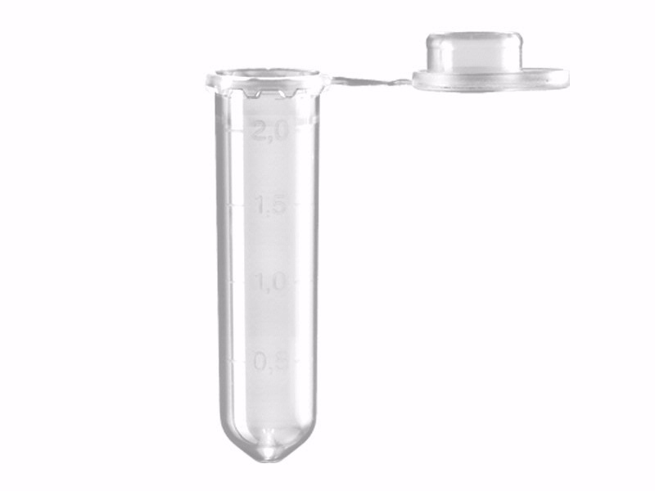
chunks). Place the tube back in the
ice. Discard this loop. Using a new
loop, repeat this process in the
second micro tube, and place that
micro tube on ice as well.

7. Have your teacher pipette 10ul of plasmid solution into your + micro tube.

8. Incubate both tubes on ice for 10 minutes. Make sure the micro testtubes are immersed in the ice (“floatie” in icewater).

9. Heat shock time. Remove the micro test tubes from the ice bath and take them to a 42º water bath. Get a timer ready because you are going to place both test-tubes in the hot water bath for EXACTLY 50 seconds. After 50 seconds, immediately put micro testtubes back in the floatie and on ice for 2 minutes.

Immediately !!

42⁰

10. Remove the floatie from the ice and place on the table top. Using a new sterile plastic pipette, add .250 ml of LB-broth to one of the tubes (and reclose it). Using a new sterile plastic pipette, add .250 ml of LB-broth to the other tube (and reclose it). Let sit on the table top for 10 minutes (room temperature).

11. Gently flick both closed tubes with your finger to mix the solution. Using a new sterile pipette, pipette .100 ml from your + micro tube onto the
LB/amp + plate.

LB/amp +

12. Using a sterile loop, spread these suspensions evenly around the surface of the LB/AMP + plates by quickly “skating” (lightly) the flat surface of the loop back and forth across the surface of the plate.

LB/amp +

13. Using another new sterile pipette, pipette .100 ml from your -- micro tube onto the LB/amp - plate. Then pipette .100 ml from your - micro tube onto the LB - plate.

LB/amp -
LB -

14. Using a new sterile loop, spread these suspensions evenly around the surface of these two agar plates by quickly “skating” (lightly) the flat surface of the loop back and forth across the surface of the plate.

15. Stack up your plates and tape them together with blue tape. Using a black sharpie, put your group’s name on the blue tape. Give your stack to the teacher to put into the 37º incubator.

